1. Scenario client want to see container ,if I give local server access to come into container the will made any changes in local server I will secure my local server only give container
2. Create 1 directory in root folder
3. Then go to create docker image file inside of a created directory (here provide password for client and client username )
4. Give execitable permission for this file
5. 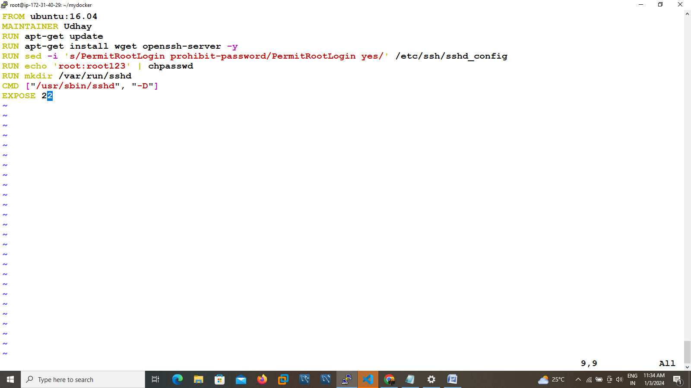

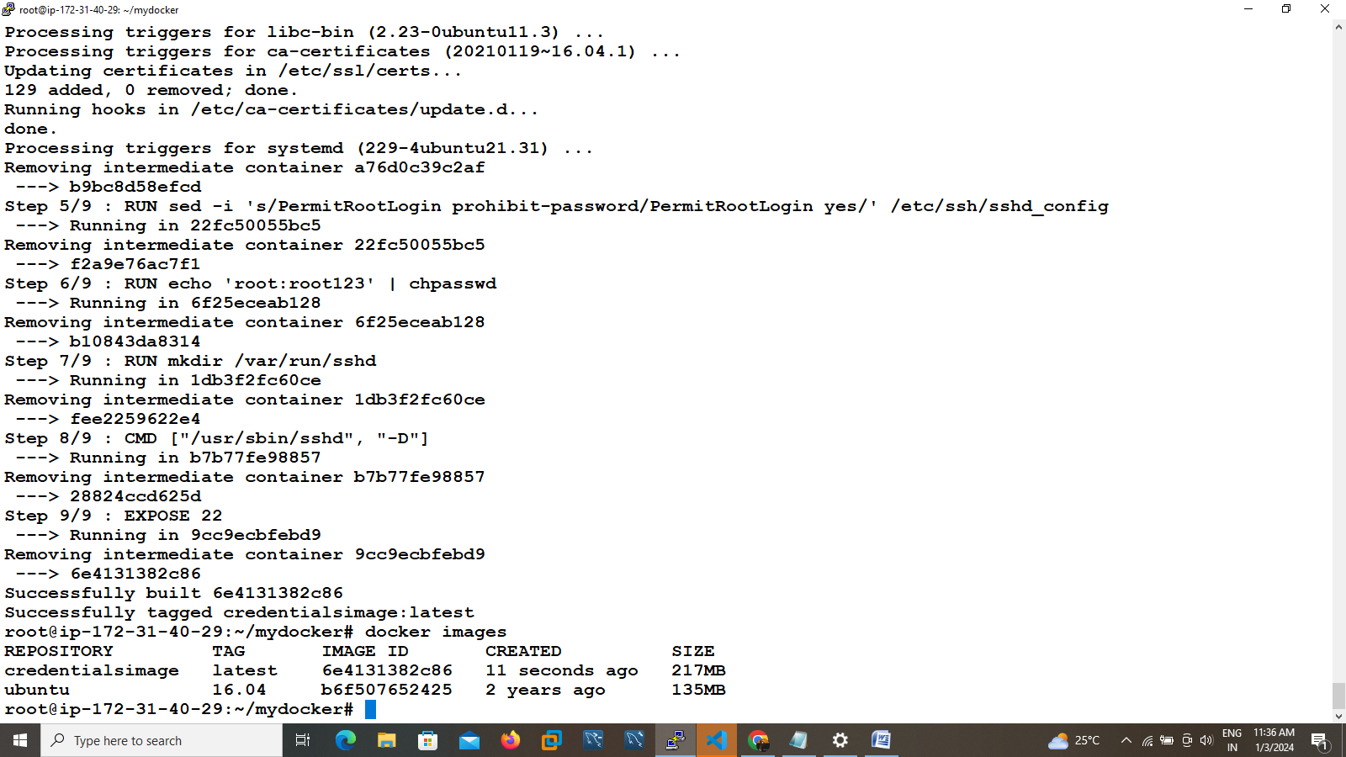

1. Run the file it will create one image name called as credentials images
2. Run the container

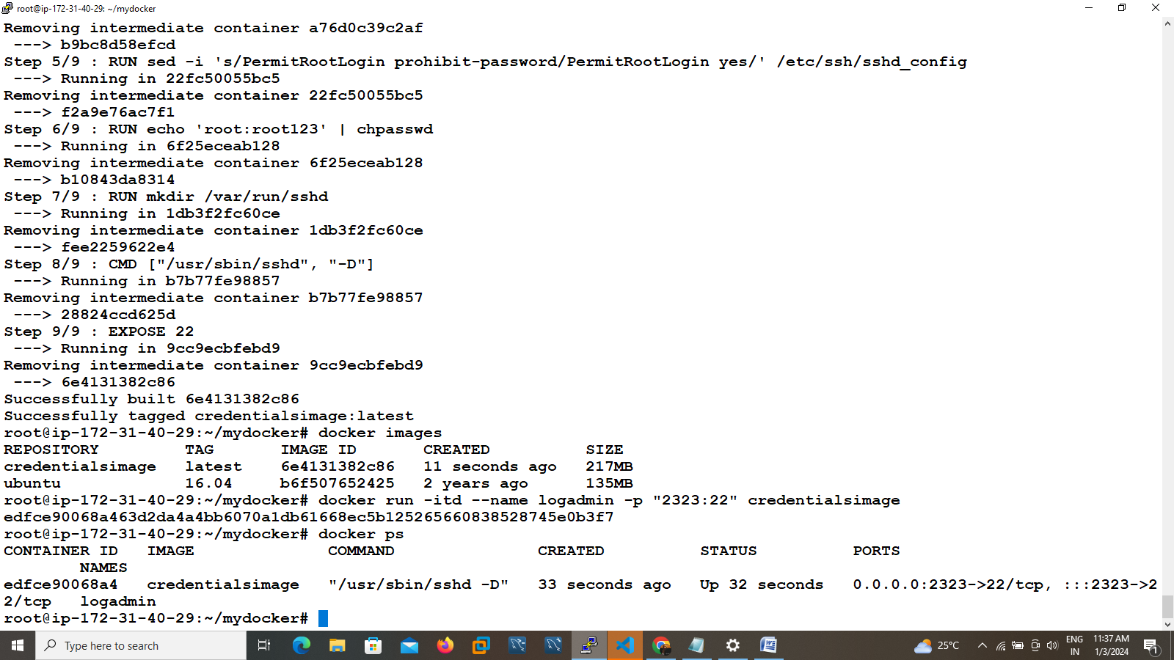

8)login to putty with ip address and port forwarded port I need key fill give username as root and password give root123 then succefully access container. 